WEEK 0
ROLL NO:241801277
NAME:SUBHA SRI.S
ALGORITHM AND FLOWCHART
1.CALCULATE AREA AND PERIMETER
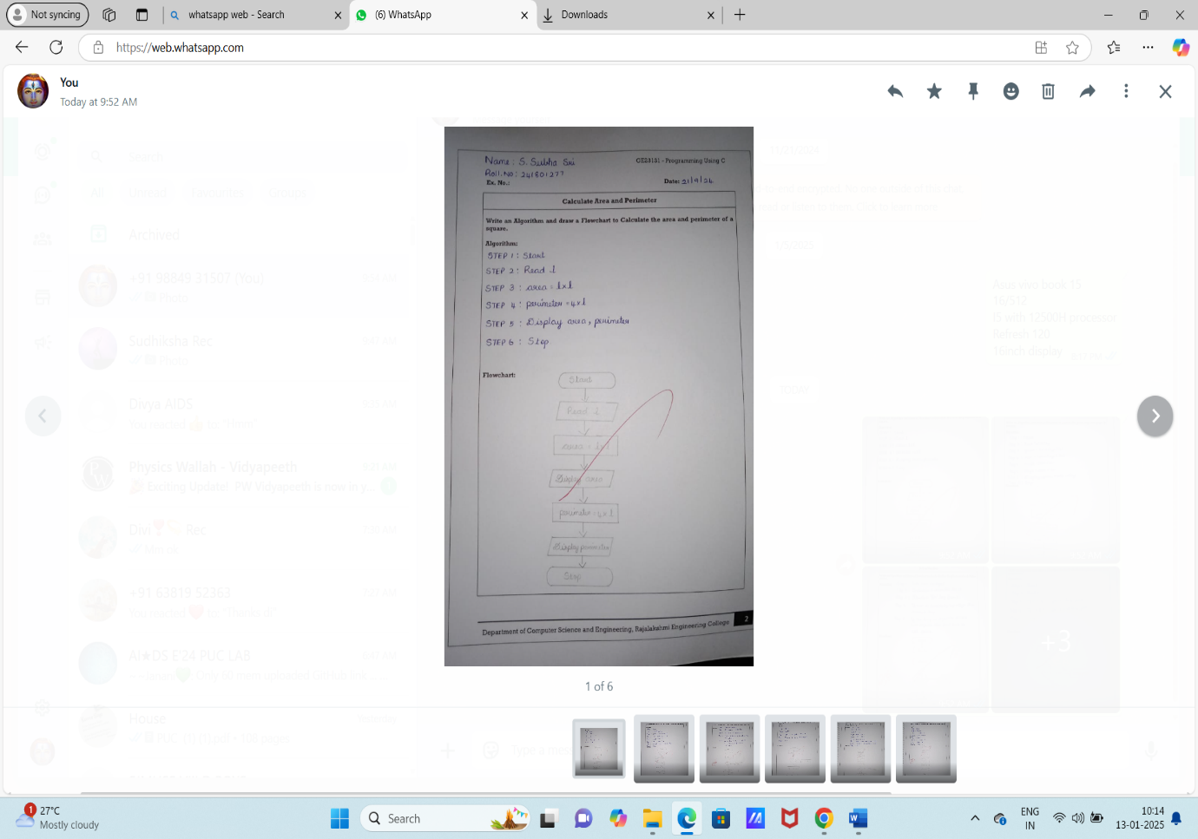
2.DAYS TO CONVERSION
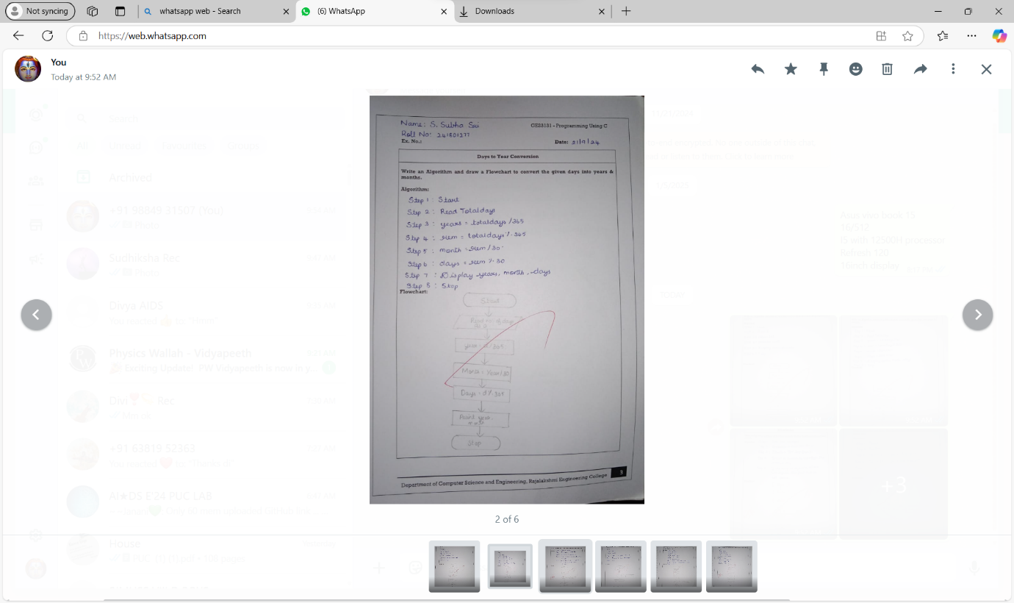
3.PRIME NUMBER
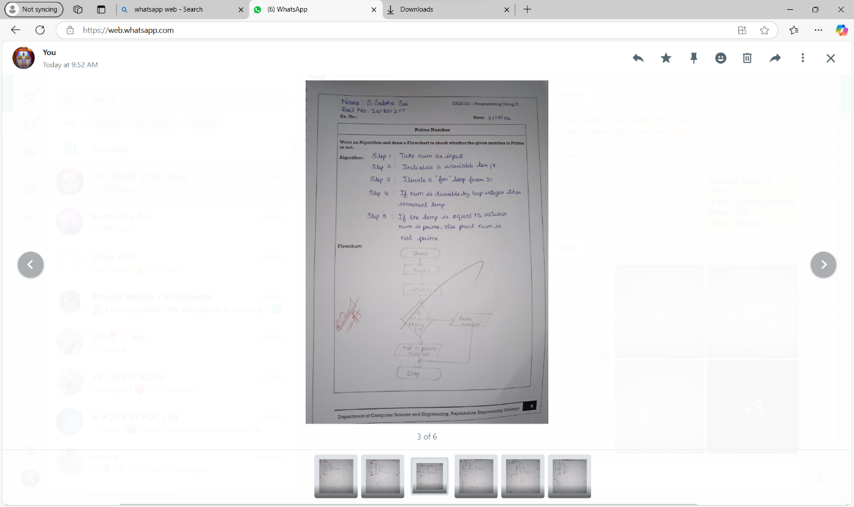
4.LEAP YEAR
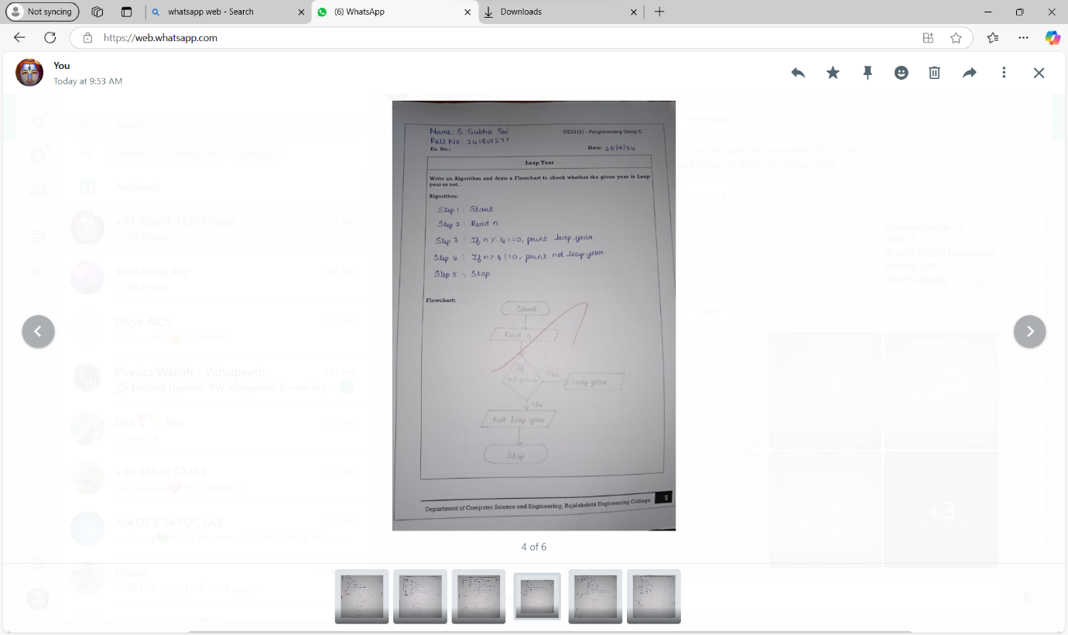

5.PALINDROME NUMBER
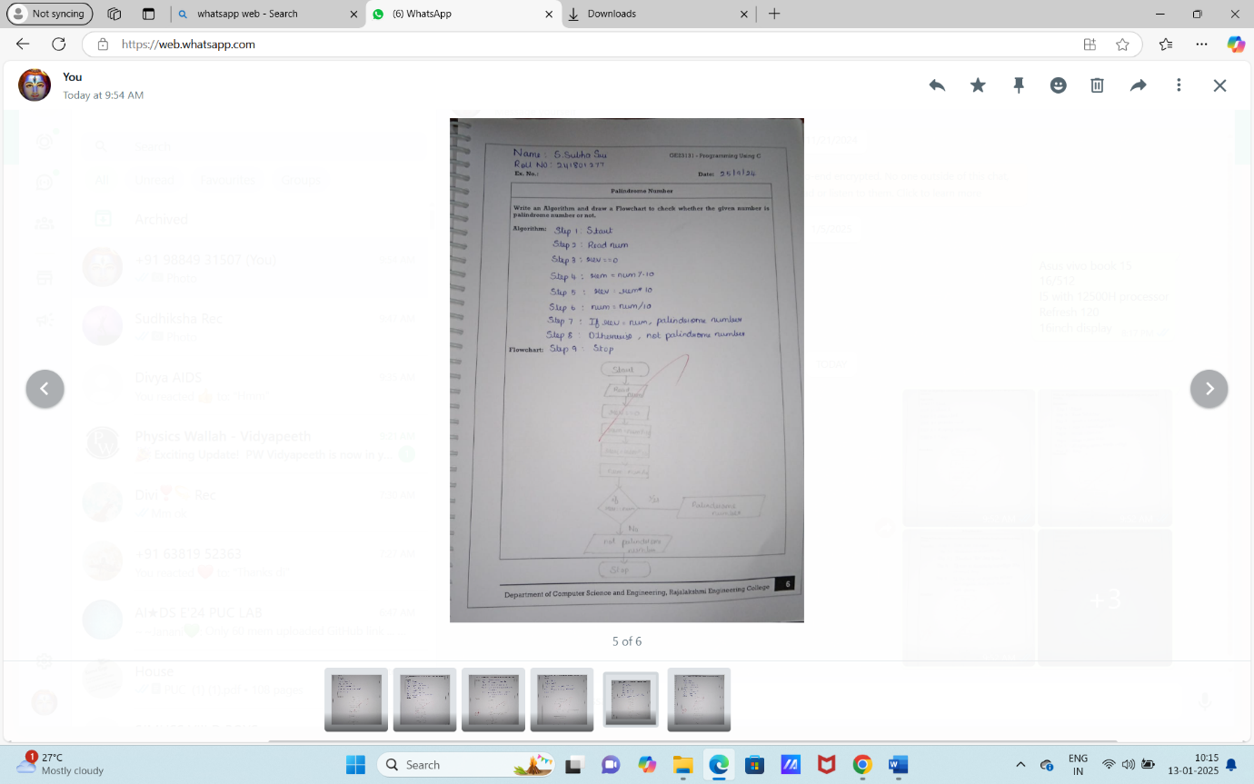

6.SUM OF DIGITS

